## Exp. **Design a system for car stereo systems such that whenever the increase volume button is pressed, a red background given by red LED blinks the number of times the button is pressed.**

Circuit Diagram:

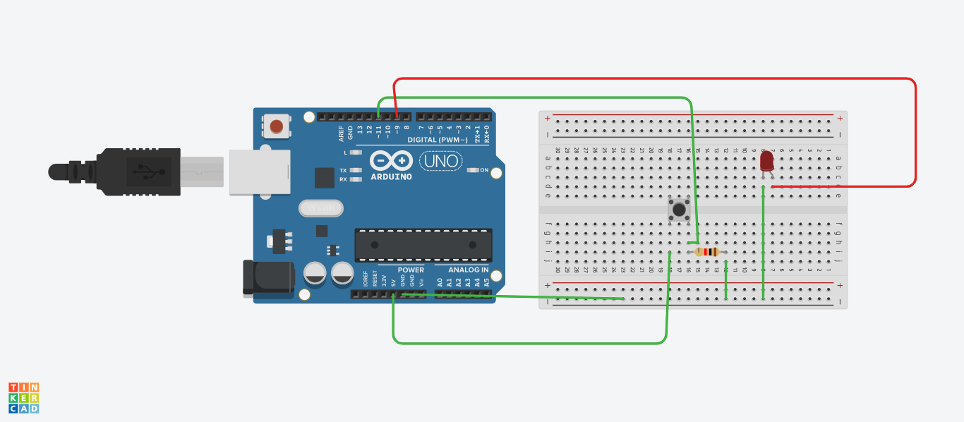

Theory

## **Concept Used** : whenever the increase volume button is pressed, a red background given by red LED blinks the number of times the button is pressed.

**Learning & Observations:**

The led light blinks when volume button is pressed

**Problems & Troubleshooting**:

1. Problem in fixing wire from bread board to arduino.
2. Problem in doing arduino programming.

Precautions:

1. Correct conection of negative and positive terminal of led.
2. Don’t put arduino near water.
3. Check the USB port of computer is working .
4. Check the arduino software and select the correct port (in which arduino is connected).

Learning Outcome:

1. LED light glow with respect to volume button.
2. Arduino function as a controller in led chaser.
3. Bread board is used to organize the circuit.

**Coding:**

boolean val = 0;

void setup()

{

pinMode(9, OUTPUT);

pinMode(11, INPUT);

}

void loop()

{

int c =0;

val = digitalRead(11);

if(val==HIGH)

{

c++;

}

else

{

digitalWrite(9,LOW);

}

for(int i=0;i<c;i++)

{

digitalWrite(9,HIGH);

delay(100);

digitalWrite(9,LOW);

delay(100);

}

}